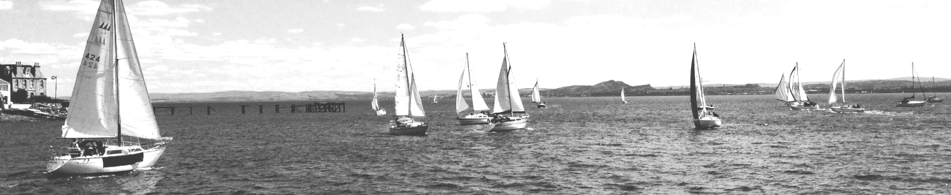

Aberdour
Boat Club

An excellent season so far for the Club, with membership growing very strongly, and new boats arriving in the harbour and the bay month on month.

On the water there is a Fishing Competition & BBQ on 28th June, Burntisland Sailing Club Regatta on 18th July, Aberdour Festival Beach Day on 1st August, Aberdour Festival Try a Sail 9th August, the Anstruther Festival & Muster 28th to 30th August, the PEYC 3 Inches Race on 20th September, and Crane Out 25th September

From our own sailing calendar, there were much enjoyed cruises to Granton and to Limekilns, and on 20th June Andy Ward is organising a muster of Westerly owners and their boats. Another Andy initiative: a number of nights sails are planned – not rigorous all-nighters, but an opportunity for slipping out on an evening tide to gain experience of sailing in company in the dark, and back home on the same tide (….all weather permitting – the idea is to enjoy themselves more than test themselves…!) Also planned are a Day Cruise/ Corriemar 13th June, a Day Cruise/Single Handed race 27th June, the BAD Cup 12th July, a Day Cruise/Stern Chase 25th July, the ABC Regatta 15th August, an Edinburgh Festival Cruise 22nd/23rd. August, and the end-of-season Raft Up on 12th September.
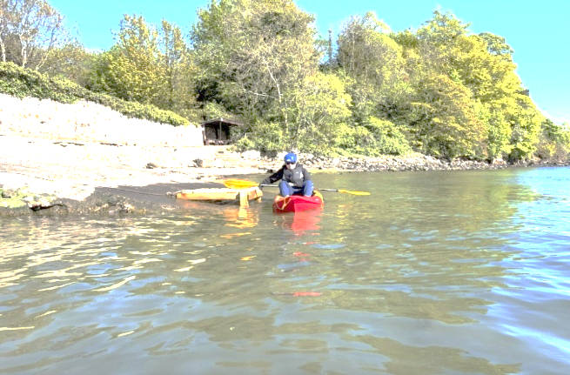
Kayaking

We’re progressing affiliation to Paddle Scotland, and member qualifications, and hope to see the start of paddling events in and around the harbour in the nor-too-distant future.

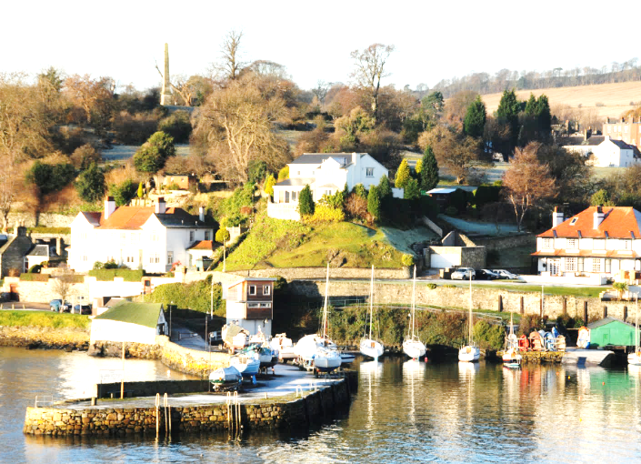
And ashore and round the harbour, work goes ahead with selecting and procuring a landing platform, ongoing sequence of work parties – general maintenance around the Club, pier and harbour, buttressing the Middle Slip with rock filled gabions, and much else besides.
Our members are amazing, bringing a huge range of skills, time and energy to the continuing process of making the Club what it is – one of the most attractive and friendly clubs on the east coast.

From the Harbourmaster Mark Maylin,
We’ve certainly had a mixed bag of weather so far this year and an uncharacteristically cold start to May, hopefully that is all about to change! With the cooperation of the Committee and members of Aberdour Boat Club, our beautiful harbour continues to be maintained for the village and visitors alike.

Since January, we have had 15 visiting yachts staying overnight, coming from as far away as Felixstowe, and several more day visitors. All available harbour moorings have now been allocated, and we are delighted to welcome several new boats to Aberdour.

Just a word of caution though, when fishing or swimming from the pier, please watch out for others, especially moving boats, as it may not always be possible to see a person in the water or a fishing line. Please avoid swimming unsupervised, and remember that even on sunny days, the water remains very cold.

Clubhouse and social
Aberdour Boat Club Events
During the summer months, Aberdour Boat Club hosts a variety of activities, including Try a Sail sessions, children's rowing races, and the club's annual regatta.

Beach Day
The clubhouse will be open during the Aberdour Festival Beach Day, serving tea, coffee, and light refreshments.

Clubhouse Hire
The clubhouse is a fantastic and unique venue, suitable for a wide range of events. The clubhouse has been hired to host numerous live music events throughout June and during the Aberdour Festival.
For further details about upcoming events or clubhouse hire, please visit the Aberdour Boat Club Facebook page and website.

From the Commodore David Mann
The Boat Club has enjoyed yet another remarkable season, with members consistently demonstrating the vibrant community spirit that makes the club an integral part of village life. This camaraderie was particularly evident during the recent work party, where volunteers arrived in force, eager to maintain our facilities and ensure everything remains in top condition.

Beyond outstanding sailing, the club has offered a lively entertainment programme, forging connections among members, families, and friends both on and off the water. These gatherings have contributed immensely to the friendly and welcoming atmosphere for which the club is well known, reinforcing its reputation as a hub of fun and fellowship.

A huge thank you to the committee and all our volunteers for their hard work and commitment to keeping the club buzzing. Thanks to their efforts, the Boat Club continues to be a place for fun, friendship, and a real community spirit—with new members joining all the time. Thank you, everyone!

And don’t forget, you can keep up with our news on www.aberdourboatclub.com !

